1. Download Android SDK (extract the files)
2. Copy the file adt-bundle-winds-x86_64-20140321 to your c drive and rename the folder(something short and meaningful)
3. Follow instructions on <http://devgirl.org/2013/09/05/phonegap-3-0-stuff-you-should-know/> to set up phonegap interface
4. Now open GitHub 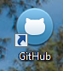 and log in
5. Select create, give the repository a name and description click create button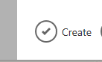.
6. Go to your file folders copy all the files under the newly created folder from www file 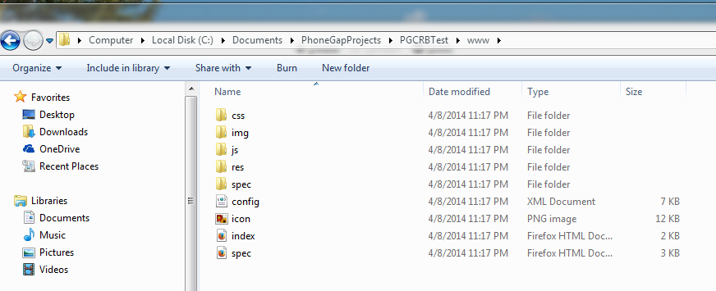
7. Paste them to the specific repository you just created in the GitHub file ( if you are not sure where that is see below 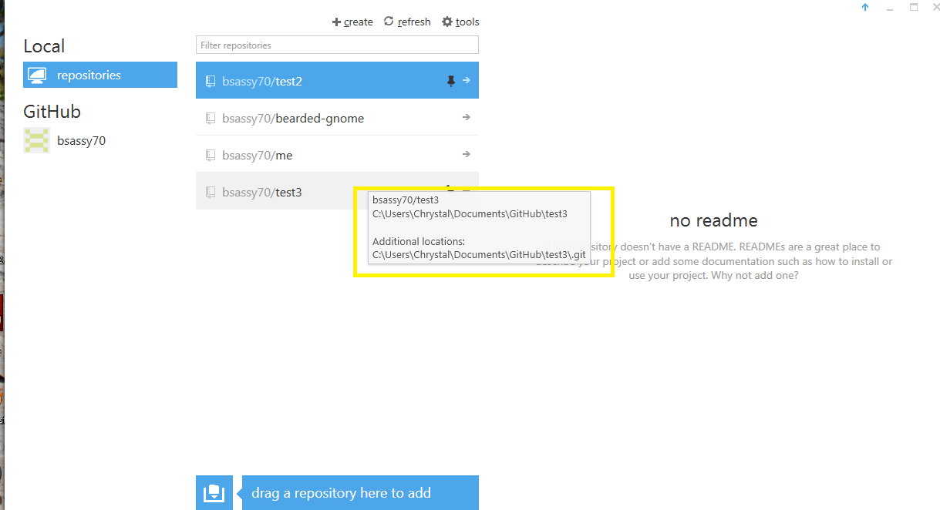
   * + 1. Once the files are in the folder return to GitHub click on your repository then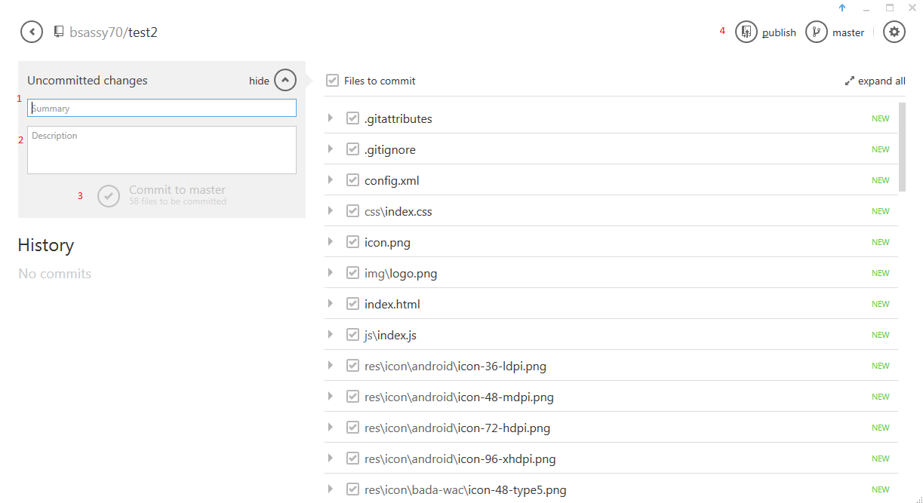
       2. Input summary(title)
       3. Input description
       4. Select commit
       5. Select publish
       6. Once publish is complete will change to sync
8. Now go to <https://build.phonegap.com/> and login
9. Is this is your first time will go to home page click on open source then select the arrow down by the box to select your repository name if not you will need to click on to start setup.
10. Choose your operating system(android) which takes you to the screen below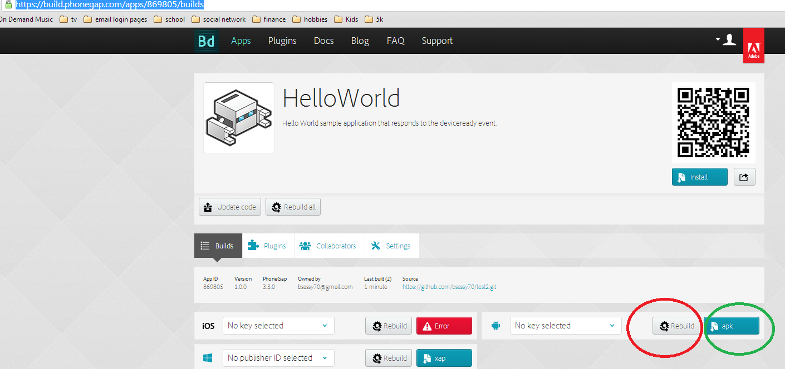
11. Select rebuild the click apk(which will download file to downloads now go to your downloads folder and copy the apx file and paste is to the android folder \sdk \platform-tools ( where the adb file is located)
12. Open the command line and eclipse application found under android folder \ eclipse
13. Run eclipse when ide opens select Window \Andriord virtual device Manager
14. Select new
15. Give AVD Name, select a device type, the target, for skin select WSVGA memory options and internal storage should be???? Question to Jamie??? then click Ok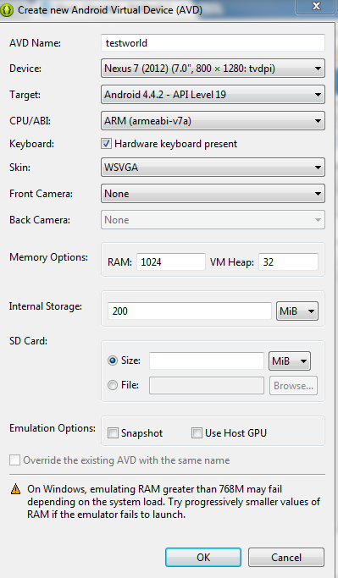
16. No you need to select your device that you selected and hit Start and launch(this will take awhile)
17. In the command line
    1. Need to locate your directory to get to c drive input cd .. after the > until you have c:>then input the file address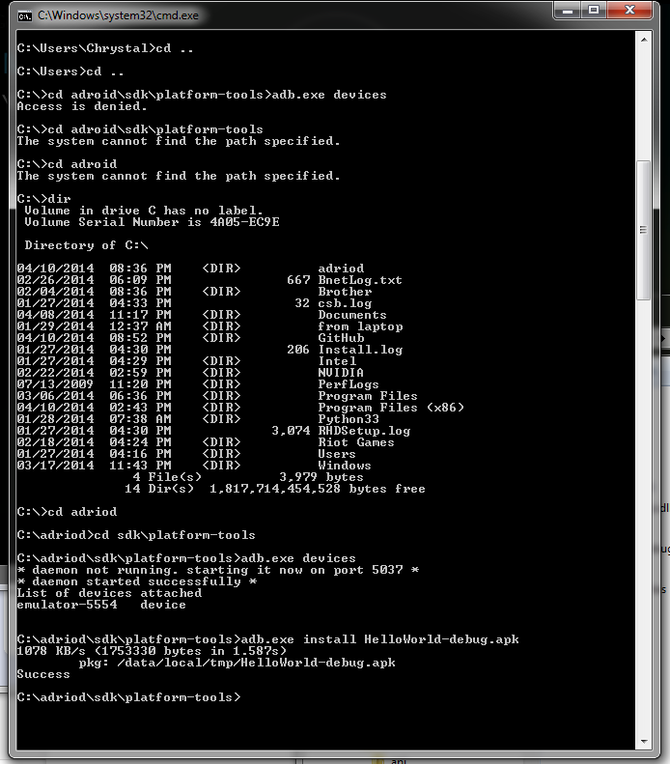
18. Once you are to the location where the adb file is save you need to input >adb.exe device and hit enter
19. Then input >adb.exe install [filename].apx
20. Return to the android virtual device and when you go to the apps screen you should see your app

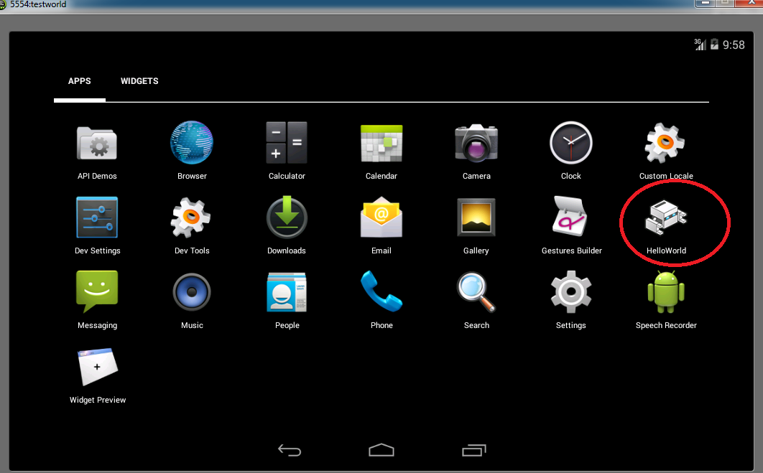

For your app you only have to change the index file and the css file to your information and your app is all set